Winged Foot Golf Club




Emergency Response Team
Manual

March 2017

This manual contains important information for members of the Emergency Response Team (ERT) of the Winged Foot Golf Club. Procedures for managing emergencies by the ERT are included in this manual.

- Medical Emergencies
- Building Evacuation
- Severe Weather
- Missing Child

Radio Channels
Ch | Department | Ch | Department
1 | Emergency | 4 | Clubhouse
2 | Golf | 5
3 | Grounds | 6

Location | Equipment
Club House (Front Desk) | AED+FA Kit
Mens Locker Room (Lower Level) | AED
Safety Cart at Bag Room (mobile) | AED+FA Kit
Beverage Station #5 (mobile) | AED+FA Kit
Golf Course Maintenance Facility | AED+FA Kit
Pool (Lifeguard Office) | AED+FA Kit
Kitchen Club House | Wall Mounted FA Kit
Golf Course Maintenance Facility | Wall Mounted FA Kit

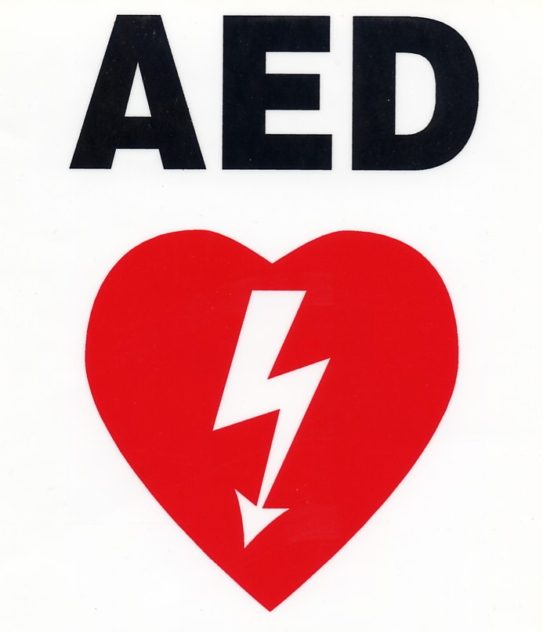
First Aid Equipment Stations

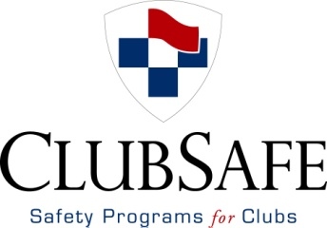

Emergency Response Team

In the event of an emergency at the Winged Foot Golf Club, immediate assistance will be provided by trained and equipped staff working together as a team. Staff nearest the incident will notify a manager or the golf pro shop as soon as possible. An Emergency Response Team (ERT) made up of department managers from all areas at the club will be notified and will respond.

Emergency Response Team (ERT)
Name | Position | Respond to
Juan Carlos Lopez | Assistant Clubhouse Manager | Clubhouse
Humberto Osorio | Maitre d’ | Clubhouse
Iliana Valerio | Dining Room Manager | Clubhouse
Steve Rabideau | Superintendent | Golf Course
Wes Neff | Asst Superintendent | Golf Course
Jamison Lapan | Asst Superintendent | Golf Course
David Zona | Caddie Master | Golf Course
Katie Weidmar | Golf Shop Manager | Golf Course
Glenn Weinberg | Pool Director | Pool
Sarah Hong | Safety Coordinator | All locations
Chris Michno | Golf Professional | Golf Course
Anne Drake | Executive Assistant | Clubhouse
Edgar Tejedo | Bag Room Manager | Golf Course

The role of the ERT is to manage any incident until Police, Fire or EMS arrives or the incident is resolved. The ERT will oversee or attend to the following critical tasks:

1. Assess Problem: Upon arrival at the incident, the ERT will assess scene safety, severity of the patient’s condition, and if more help is needed (9-1-1).

2. Call 9-1-1: If needed, the ERT will have 9-1-1 called, or confirm they have been called.

3. AED and First Aid Equipment: Staff will respond with an AED and First Aid kit to every emergency at the Club regardless of the need to use. The ERT will make sure they have been retrieved or send someone to retrieve from the nearest location.

4. Provide First Aid: Staff nearest the incident will provide first aid in accordance with their level of training (CPR, AED, Heimlich, etc). The ERT will take over managing the patient and scene.

5. Meet EMS: ERT will ensure staff have been assigned to meet EMS at the main entrance and direct to the incident. The ERT will provide EMS personnel with a verbal report on what occurred, what first aid was provided and any resultant changes.

6. Scene Control: The ERT will control the scene immediately around the patient to ensure appropriate care is given, on-lookers are controlled, patient dignity is maintained and the least amount of disruption to Club activities occurs.
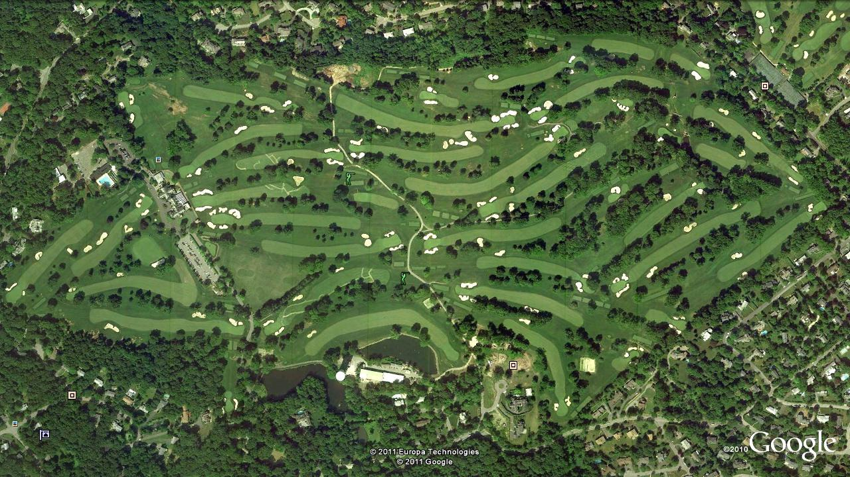
9

15
14
16
11
13
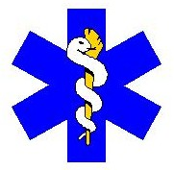
10
12
13
14


11
18
15
17
Pool
7
16
12
T
18
17
Clubhouse
6
9
8
1
1
5
10
2
4
Practice Range
8
9
7
3
2
4
5
Grounds Facility
3
6

KEY

KEY

AED + First Aid Supplies
Dedicated Safety Cart
EMS/FD Access Points
T
Entrance Roads
Evacuation Route
Telephone

Emergency Phone
Locations
East Course

4th Tee 13th Tee
5th Tee 15th Tee
6th Tee 17th Tee
7th Tee 18th Tee
9th Tee
West Course

1st Tee 13th Tee
6th Tee 15th Tee
8th Tee 16th Tee
12th Tee
AED + First Aid Equip Station
Emergency Call Box
First Aid Equipment Stations

- Clubhouse (Grille Room, Men’s LR)
- Pool
- Grounds Facility
- Golf Course Safety Cart
- Superintendent Cart


Defibrillator + First Aid Supplies
Locations

• Clubhouse (Front Desk)
• Golf Pro Shop
• Golf Course Maintenance

Dedicated Safety Cart
T
Telephone
EMS Access Points
13
18
18
East Course
West Course
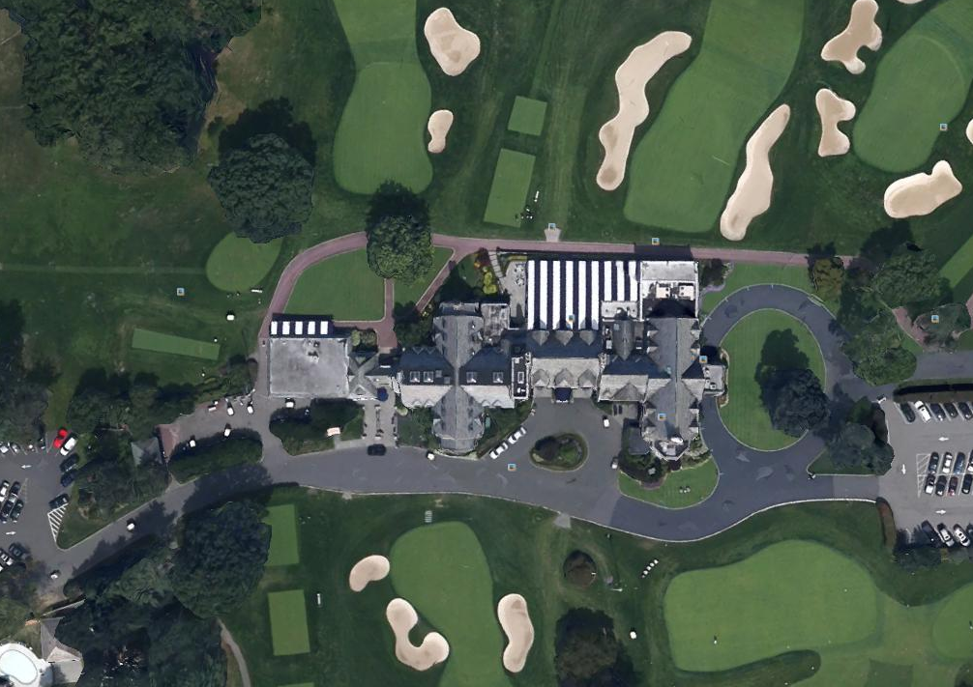

Assembly Area

Assembly Area

Assembly Area

KEY

AED + First Aid Supplies
Dedicated Safety Cart
EMS/FD Access Points
T
Entrance Roads
Evacuation Route
Telephone

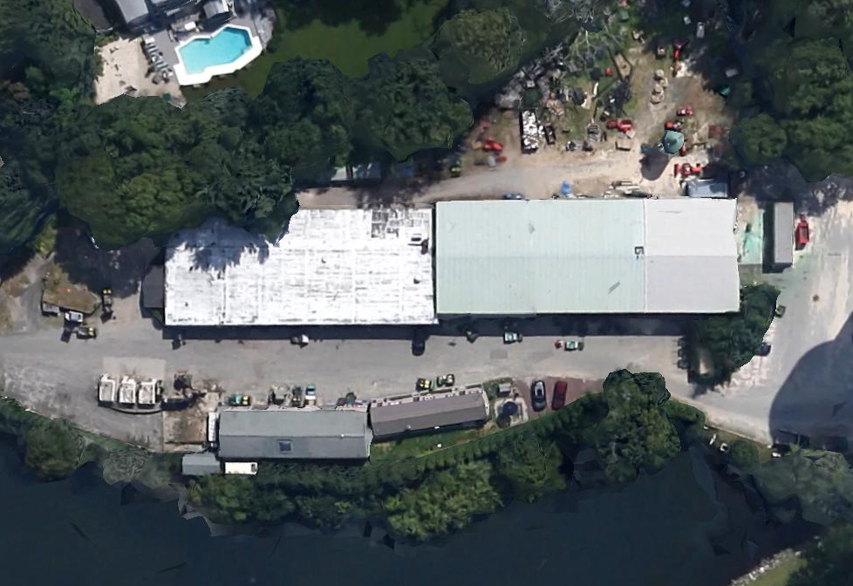
KEY

AED + First Aid Supplies
Dedicated Safety Cart
EMS/FD Access Points
T
Entrance Roads
Evacuation Route
Telephone

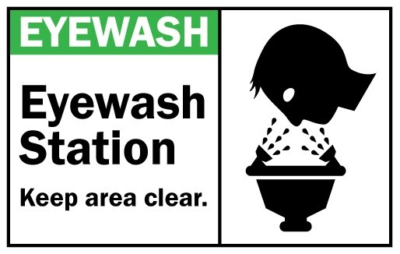
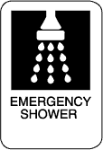


Tractor/Mower Storage

Mechanic Shop

Assembly Area

Assembly Area

Cold Storage
Office
Fuel
Gas/Diesel


Eye Wash Station
Drench Shower
Evacuation Route
Hazard Mat Storage
Key

Fire Extinguisher
First Aid Kit
Eye Wash Station
Defibrillator (AED)
Drench Shower
Pesticide Storage
Evacuation Route

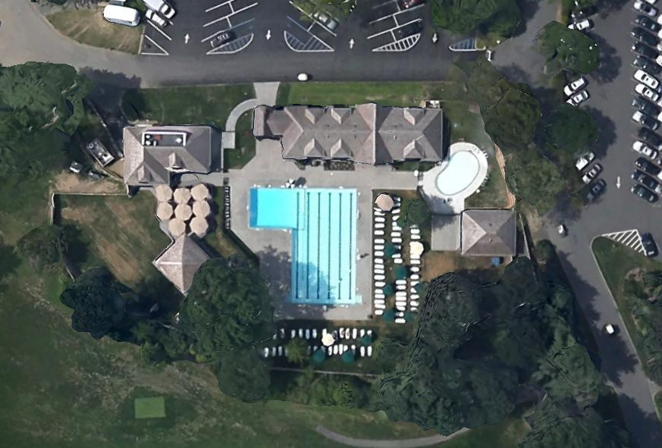

Assembly Area
Medical Emergencies
‘If the Front Desk is unavailable, call 9-1-1 directly and alert a manager.’
‘Staff will bring an AED and First Aid Kit to every emergency’

An emergency in any area of the Club requires good staff communications and teamwork to be managed effectively. Staff nearest the incident will notify a Manager, the Front Desk or Pro Shop and initiate first aid until additional help arrives.

Medical Emergencies

Staff nearest Incident

Alert
A Manager
Front Desk
or
Pro Shop
If needed,
Call 9-1-1

Alert ERT on Radio

Golf Course
Emergencies
Club House Locker Rooms Emergencies
Pool
Emergencies
Golf Course Maintenance

Lifeguards
Nearest Staff
Grounds Staff
Golf Starter

Superintendent
Pool Director
A Manager
Superintendent

Front Desk
Front Desk
Front Desk
Asst Superintendents

Club Manager
Club Manager
Club Manager
Front Desk

Club Manager
Assess Incident

CPR/AED
Obstructed Airway
Control Bleeding
Comfort Reassurance
Provide
First Aid

Meet
EMS

Meet and Direct
Provide report
Assist as needed

Scene Safety
Victims Problem
Verify 9-1-1 called
Verify AED present
Crowd Control

ERT First Aid Protocol
Start Here
Call 9-1-1:
Wait for
Fire, Police or EMS. Do not endanger yourself.
NO
Assess Patient
Are they Responsive?
YES
Is the Victim:

Injured?
Bleeding?
In Pain?
Having trouble Breathing?
Disoriented/Confused?
NO
Does the Victim request Medical assistance?
NO
Assist. Notify Manager if not already present.
YES
Are they Breathing?
NO
Begin CPR
Apply AED as soon as it is available.
See Cardiac Arrest Protocol
Control Severe Bleeding

Do not move if injured

Provide Comfort and Assurance

Wait for EMS
YES
Is it Safe to Approach the Patient?
NO
YES
Call 9-1-1
Get AED
Are they Choking?
YES
Perform
Heimlich
Maneuver
NO
Call 9-1-1
Call 9-1-1

Unresponsive
+
Not Breathing or Not Breathing Normally
Verify Cardiac Arrest
Call 9-1-1 (or send someone to call)
Get the AED (or send someone to retrieve)
Start CPR with Chest Compressions*
Open Airway, Give 2 Breaths
Continue 30 Chest Compressions, 2 Breaths
*Perform chest compressions until a pocket mask is available, each AED is equipped with one.
AED
Turn on, put on AED
(As soon as AED arrives)

1. Follow voice prompts
2. Remove clothing from chest
3. Wipe excess moisture and shave chest hair if needed
4. Apply AED PADS to bare chest
AED Automatically Analyzes
Do Not touch Victim
Shock Advised
Clear victim visually and verbally.
Deliver Shock
Follow AED Voice Prompts
No Shock Advised
Begin CPR

Continue CPR
(2 minutes)

Start Here
Cardiac Arrest Protocol
Club House Evacuation Procedures

When the Fire Alarm sounds(daytime, evening):
1. The CM (or MOD) and Facilities Manager meet at Front Desk to determine source of alarm
2 If evacuation is needed, Managers will assist members and guests to exits and the designated assembly areas.
Prepared by ClubSafe, Inc.
3. Managers will report to the CM when area is clear of all occupants, or a problem exists.
4. Elderly and Physically Disabled will be assigned a staff person to assist them.
5. CM will communicate directly with the Fire Department “Incident Commander”.

CM(or MOD)
@
Front Lobby
Incident Commander
(Fire Dept)
Facilities Manager

Responsible for:
- Alarm Location
- Building Systems

CH, F&B Managers

Accounting
Chef
Locker Room Staff

Responsible for:
- Main Kitchen

Responsible for:
- All 1st Floor
- Dining
- Grill Room

- All Locker Rooms
- Showers

- Admin Offices
- Board Room

Club House Assembly Areas
Front Exits = Across Drive to Grass
Front Door = Circle
Rear Exits = Grass

Severe Weather

Most severe weather situations provide some degree of warning or buildup, which will allow for necessary preparations to be implemented. In other cases, a sudden storm may produce damaging winds or lightning and be a threat to unprepared members and staff.

Severe Weather Notification

Watch Potential 36-72hrs
Warning Imminent 24hrs, or seen

1 Long Horn- Evacuate Course

Lightning
Tornado
Hurricane/Winter Storm
Winds

Seek Shelter
- Club House
- Grounds Building
- Pool House

Seek Shelter
- Club House
- Grounds Building
- Pool House

Seek Shelter
- Club House
- Grounds Building
- Pool House

Pre Event
- Department Checklists
- Prepare Facility
- Close Club?
- On Property Provisions

- Away from windows
- Low central location in building
- Away from outside walls
Post Event
- Assessment
- Clean up
- Reopen Club

3 Short Horns – Resume Outdoor Activities

ERT

Assess Injuries
Provide First Aid
Meet EMS

Missing Child Procedures
Missing Child Procedures:

STEP 1: Obtain a detailed description of the child.
STEP 2: Announce a “Missing Child”
STEP 3: If not found within10 minutes, Call Police.
STEP 4: If found unharmed, reunite with parent or guardian.
STEP 5: If accompanied by someone other than parent or guardian,
Use reasonable efforts to delay individual until police arrive.
STEP 6: Conclude by announcing “Missing Child Cancelled”.

Communications between ERT members is the key to a successful recovery
Alert all Departments
- Missing Child Procedures in affect
- Detailed Description
- Advise CM who contacts Parents

Responsible for:
- Mens’ and Women’s Locker Rooms

Responsible for:
- Golf Pro Shop
- Bag Room
- Cart Storage
- Practice Range
- Golf Course
- Golf Maintenance

Responsible for:
Day Camp Areas
Pool

Locker Room Attendants
Alert a Manager
Pool Lifeguards
Golf and Grounds
F&B Manager
Responsible for:
Club House

Nearest Staff Advised
1. Get Detailed Description
- Name, Last Seen
- Sex, Height, Weight, Hair color
- Clothes, shoes

Notes

